Guide to validate Customer Portal – NetSuite Integration

1. Validate sales order created in NetSuite through Customer Portal (Grimco)
- Identify by memo field for now which will contain - “Created by Celigo”
- Order created from the files present in the SFTP Staging server
- Path to fetch orders data – “/public_html/public/csvfiles/Grimco/Grimco_PO_Files”
- Backup path – “/public_html/public/csvfiles/Grimco/GPOF_Backup”
- Auto run is set to run in every 15 minutes.

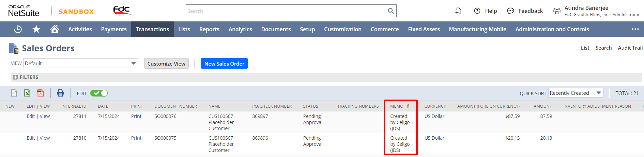

2. Validate sales order created in NetSuite through Customer Portal (JDS)
- Identiy by memo field for now which will contain – “Created by Celigo (JDS)”
- Order created from the files present in the FTP Production server
- Path to fetch – “/files/csv-invoices/testfolder/JDS_PO_Files”
- Backup path – “/files/csv-invoices/testfolder/JDSPOF_Backup”
- These are the test path created for development as it is a production server, after your validation we will change it to the main paths
- Auto run is set to run in every 15 minutes

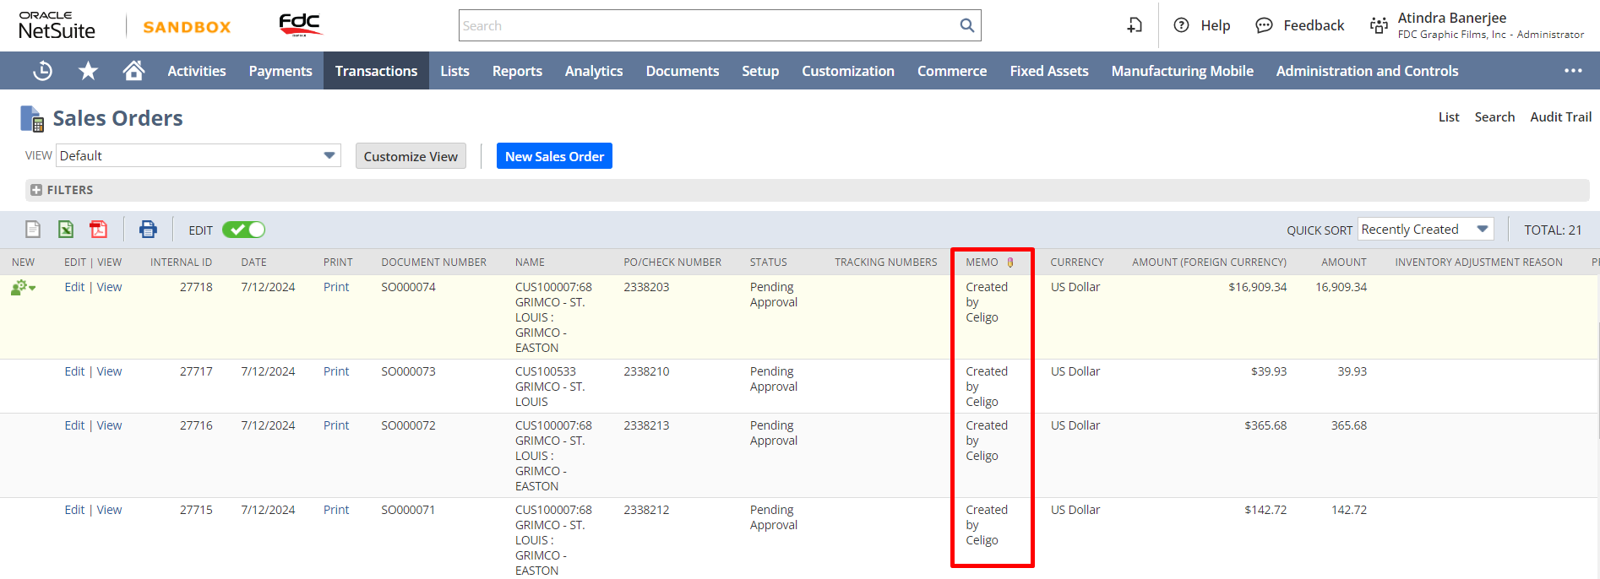

3. Verify Customer statement report
- SFTP Staging server
- Path of file – “/public_html/public/csvfiles/zeeshanCustomerStatement.csv”.
- After your confirmation we will change it name to the original.
- Auto run is set to run once daily at 12:05 AM EST

4. Verify Open Invoice & Credit Memo report
- SFTP Staging server
- Path of file – “/public_html/public/csvfiles/zeeshanOpenInvoice.csv”
- After your confirmation we will change it name to the original.
- Auto run is set to run once daily at 10:05 AM EST

5. Verify Open Sales Order report
- SFTP Staging server
- Path of file – ““/public_html/public/csvfiles/zeeshanOpenSalesOrder.csv”
- After your confirmation we will change it name to the original.
- Auto run is set to run in every 15 minutes.

